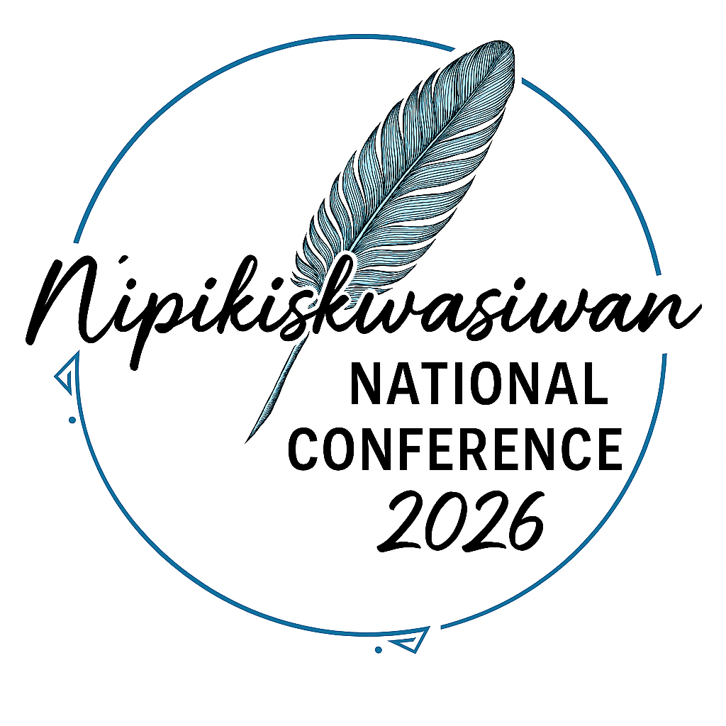
NIPIKISKWASIWAN NATIONAL CONFERENCE 2026
Restoring Balance
Indigenous Pathways to Healing and Wellness for Our Children
Transforming Trauma Through Healing: Indigenous Healing in
Action Aligned with C92 Federal Law
Location: Edmonton EXPO Center
Date: April 7-9, 2026

Registration Form
Name: Click or tap here to enter text.
Organization (if applicable): Click or tap here to enter text.
Phone number: Click or tap here to enter text.
Email address: Click or tap here to enter text.
How did you hear about us? Click or tap here to enter text.
Date: Click or tap to enter a date.
Number of people attending: Click or tap here to enter text.
Do you need hotel accommodation: Click or tap here to enter text.
Contact Information:
For more information, please contact Charlotte Gibbs with Nipikiskwasiwan Consulting Group at (409) 444-6025 or (780) 915-9712. Email form and payments can be made via etransfer: info@nipikiskwasiwan.com. Payment must be received for your attendance to confirmed. Please reference name of organization or name of attendee on all etransfers.

